# Background

* Modelling insulin detemir

The glucose-insulin model used is:

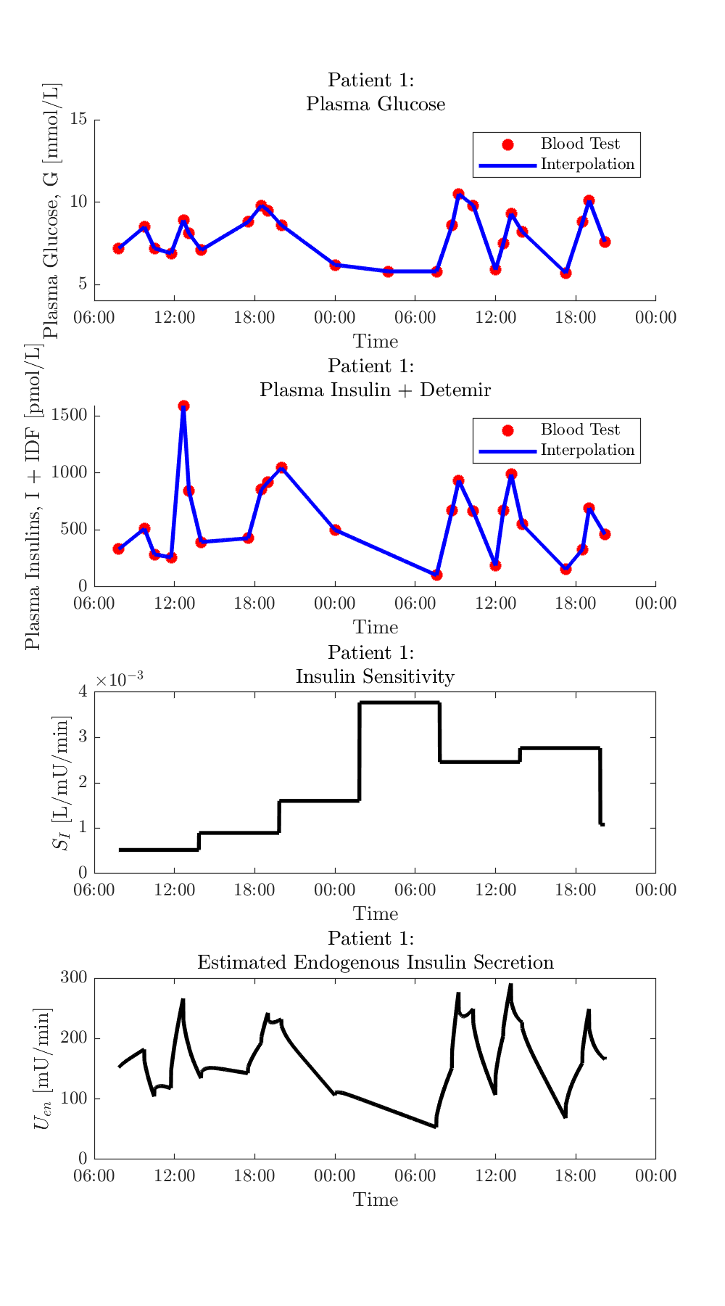



Figure

# The Approach

* Attempting to fit nL and xL using multiple linear regression

1. Use van Cauter method to estimate .
2. Forward simulate the ID model to get (unbound insulin Detemir in plasma)
3. Subtract from measured , and interpolate over simulation time to get (human insulin in plasma)
4. Use the analytical solution for the Q equation to find :

where and .

1. Integrate the I equation and assemble into the appropriate form for fitting nL/xL
2. Solve the integrals at each minute to form A and b matrices.
3. Solve with MLR (MATLAB’s A\b) to get nL/xL.

# The Problem

First attempts fitting nL and xL data

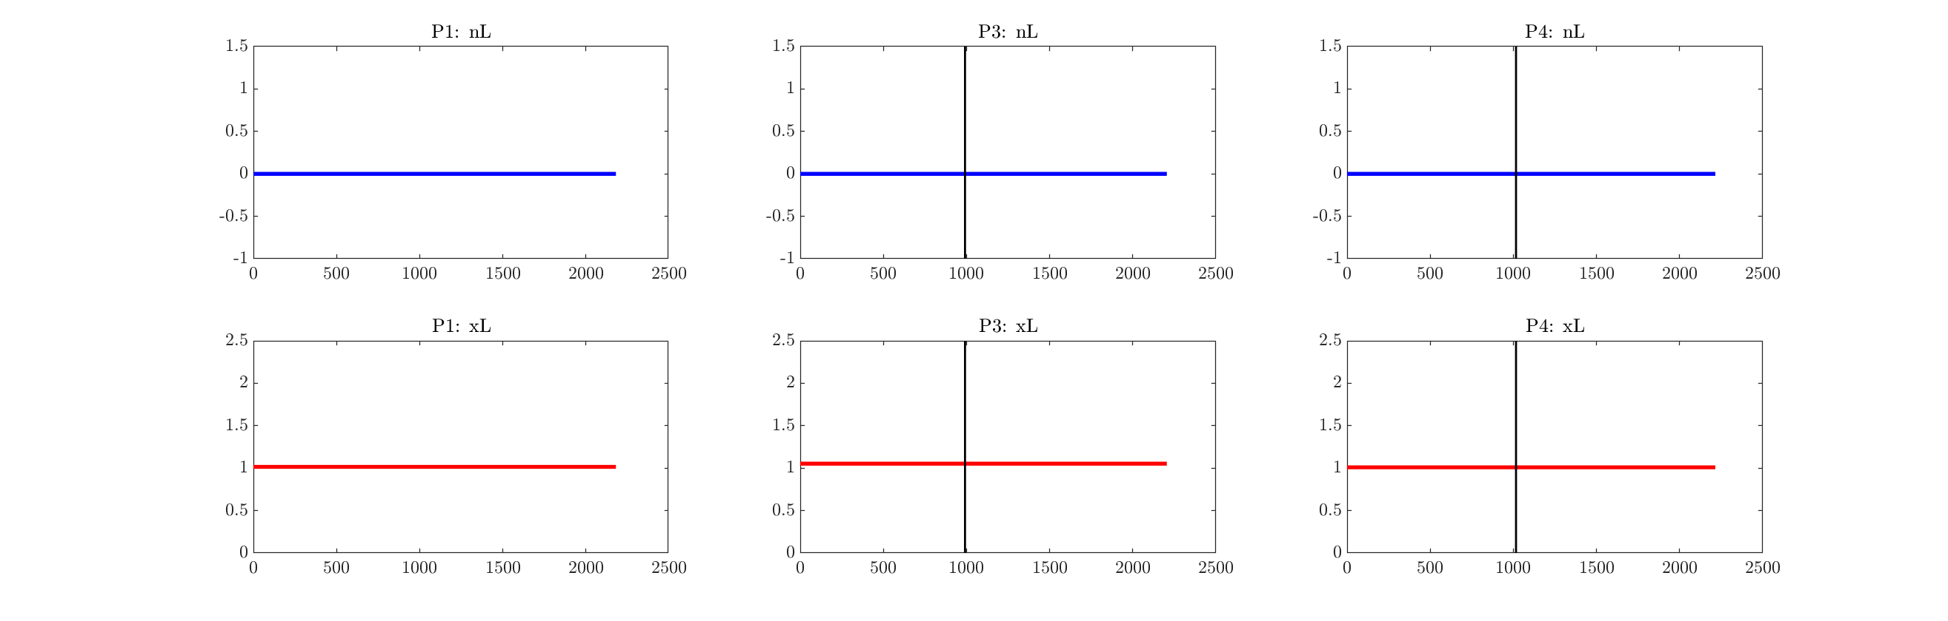

Plotting each individual term of the integrated term reveals what’s going on with this fit:

